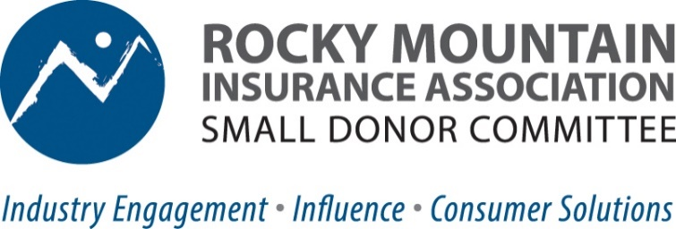

Why should Colorado insurance agents care about state politics? “I’m too busy running a business and serving my customers to pay attention to what happens at the Colorado State Capitol.” That’s what we often hear, but unfortunately, lawmakers are paying attention to YOU. Critical decisions are currently being made with little insurance knowledge, and lawmakers are proposing legislative “solutions” that would mandate how policies are sold, quoted, and priced, impacting ALL agents—independent, captive, direct. New state laws are being considered that will directly affect your book of business, income, and exposure to lawsuits.
So, how can we make a difference? Together is the answer. We need to invest in the insurance industry’s political clout by joining the Rocky Mountain Insurance Association’s Small Donor Committee. Here’s how it works:
- $50 contribution per year by you translates into support for candidates up to $5350 State Legislative Candidates, $12,250 Statewide Candidates. Pooling small donations from the P & C insurance industry to back business-friendly candidates who understand and support our issues.
- Join the RMIA Small Donor Committee today through RMIA’s secure online payment system. (Maximum Annual Contribution is $50)
  - Sign Up Options:
    - Via RMIA website: Property & Casualty Insurance Resources for Agents (rmiia.org)
    - Via QR Code Checkout:


Why a Small Donor Committee? It’s vital to support BOTH Political Action Committees (PAC) AND SDCs. A SDC is a political contribution utilized by industries like ours with large numbers of potential donors, like teachers, unions, lawyers who donate a small amount and the law then allows for larger contributions to candidates. Elected officials also view SDC contributions as support from “the little guy” and united individual influencers. A united insurance industry led by agents is the most powerful.

Game Changers: Colorado Legislative Decisions Impacting Insurance
- Colorado FAIR Plan: RMIA and insurance lobbyists were able to leverage legislator relationships to guide the passage and put guardrails in place as the state creates the first FAIR Plan (state property insurance fund of last resort) in 40 years. Insurance marketplace stakes are high as Colorado’s affordability and availability hang in the balance. The industry needs to maintain influence in the face of political pressure.
- BI-Partisan Success Story: HB22-1357 would’ve devastated agents’ income and put some out of business by capping revenue and forcing rates to be subject to onerous CO DOI prior approval—grinding rate approval to a halt and likely driving some smaller insurers out of the market. Business-friendly democrats with the power to pass the bill instead joined republicans in unanimously defeating it—an example of how relationships on both sides of the aisle can influence positive outcomes.
The Rocky Mountain Insurance Association Small Donor Committee is a bi-partisan organization that works to elect candidates who support the insurance industry’s efforts to preserve Colorado’s stable, competitive property and casualty insurance marketplace & tort environment. For more information contact: Jurree Scherrer, Operations Director, RMIA 303-790-0216 / jurree@rmiia.org.

